# Scenario #: Manual Airlock Inner to Outer

## Scenario Description

* This scenario is intended to check that the Airlock operates properly in manual mode, allowing someone to travel through the airlock from the inside

## Version Control

|  |  |  |  |
| --- | --- | --- | --- |
| Version # | Date | Author | Description |
| 0.1 | 27/11/2022 | Lachlan Nealon | Initial Draft |
| 1.0 | 2/12/2022 | Lachlan Nealon | Initial Version |

## Test Scripts

The following scripts will cover this scenario:

* 1.1 Airlock – Someone travelling from inside to outside in manual

## Use Case

* Airlock

## Test Components/Requirements

This test scenario covers the following high-level test requirements (see scripts below for specific requirements covered by each test script):

* Success Scenario
* Inner door is opened and closed
* The airlock equalizes pressure with outside and inner pressure
* Outer door is opened
* Airlock is sealed

## User Groups

* Airlock User : Opens and closes inner and outer door, equalizes pressure within airlock

## Script #: Normal flow - In manual, a person successfully travels through the Airlock from the inside

### Script Description

* Pass through airlock in auto mode from inside to outside when external environment pressure is less than internal cabin pressure
* Testing Requirements

This test script covers the following specific testing requirements:

* Inner door is opened and closed
* The user equalizes pressure with outside and inside pressure
* Outer door is opened
* Airlock is sealed

### Setup

* Airlock must be sealed
* The external pressure must be initialized lower then interior pressure
* Airlock should be in manual operation mode

### Test Data

|  |  |
| --- | --- |
| Data | Value |
| External Pressure | 1 |
| Internal Pressure | 5 |

### Teardown

* No necessary tear down actions

### Script Steps

| **Step #** | **Test Action** | **Expected Results** | **Pass/ Fail** |
| --- | --- | --- | --- |
| 1 | Equalize with internal Pressure “EI” | lock pressure is equalized to internal pressure | P |
| 2 | Open internal door “OI” | internal door is opened | P |
| 3 | Close internal Door “CI” | internal door is closed  Airlock is sealed | P |
| 4 | Equalize with external Pressure “EX” | Lock pressure is equalized to external Pressure | P |
| 5 | Open external door “OX” | external door is Opened | P |
| 6 | Close external door “CX” | external door is closed  Airlock is sealed | P |

ScreenShots

Step

1 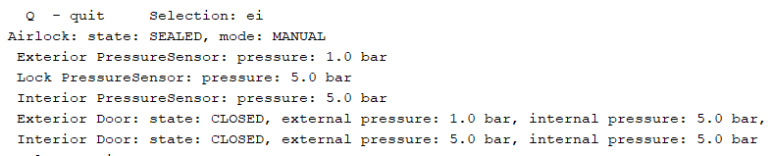

2

3

4

5

6

### Test Execution

|  |  |  |  |  |
| --- | --- | --- | --- | --- |
| Date | Tester | Test ID | Test Phase | Status |
| 2/12/22 | Lachlan Nealon | LachlanNealon | System Cycle 2 | Passed |